ASP.NET Core 8.0 Web API
Aim:
To create an ASP.NET Core Web API, configure Swagger, test Web API methods using Swagger UI and Postman, and modify the Employee controller route.
Objectives:
- Demonstrate Swagger installation and Web API listing in the browser using Swashbuckle.AspNetCore.
- Demonstrate Swagger configuration using AddSwaggerGen(), UseSwagger(), and UseSwaggerUI().
- Demonstrate the use of Postman to test Web API methods.
- Demonstrate the use of Route attributes.
- Create a simple Web API with Read and Write actions.
Tools Used:
- Visual Studio 2026
- ASP.NET Core Web API (.NET 10)
- C#
- Swashbuckle.AspNetCore
- Swagger UI
- Postman
Procedure:

Step 1: Create Web API Project
Created an ASP.NET Core Web API project named EmployeeWebAPI in Visual Studio.

Step 2: Install Swagger
Installed the Swashbuckle.AspNetCore NuGet package and configured Swagger in Program.cs using:
- AddSwaggerGen()
- UseSwagger()
- UseSwaggerUI()

Step 3: Execute Swagger
Executed the application and opened the Swagger UI. Verified that the controllers and HTTP methods were displayed successfully.

Step 4: Test Values Controller
Executed the GET method of the ValuesController using Swagger and verified the response.

Step 5: Test Using Postman

Tested the following endpoints using Postman:
- GET /api/Values
- GET /api/Emp
Verified that the response body and 200 OK status were returned.

Step 6: Modify Employee Route
Modified the Employee controller route from the default route to:
- [Route("api/Emp")]
Verified the modified route using both Swagger and Postman.
HTTP Methods Used:
HTTP Method | Purpose
GET | Retrieve data
POST | Create data
PUT | Update data
DELETE | Delete data

Figure 1: Swagger Home Page showing Employee and Values controllers.
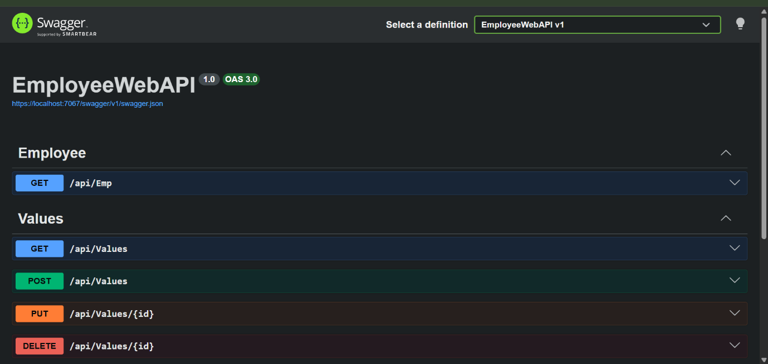

Figure 2: Swagger GET /api/Emp response.
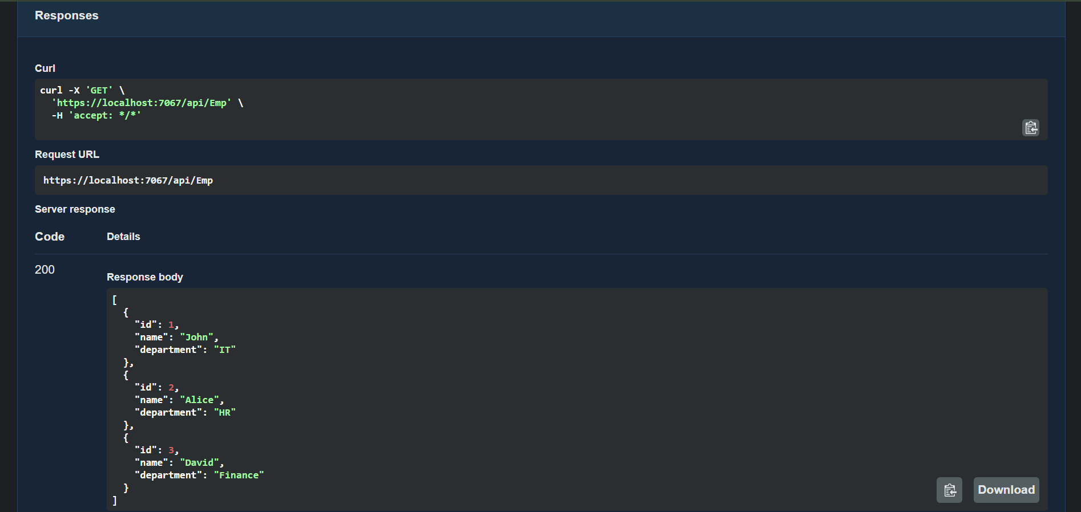

Figure 3: Postman GET /api/Values.
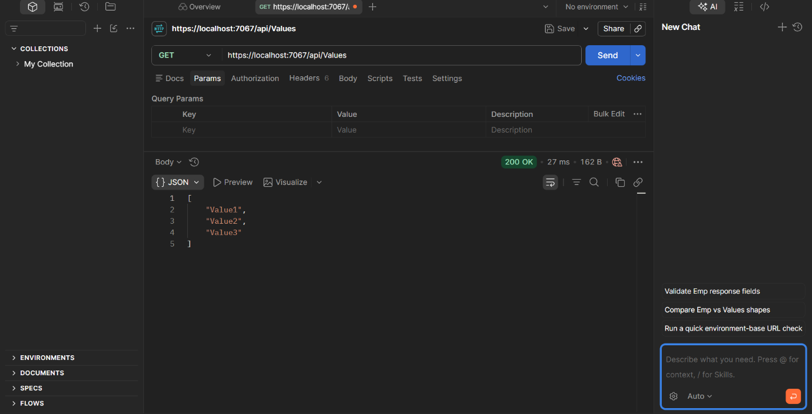

Figure 4: Postman GET /api/Emp
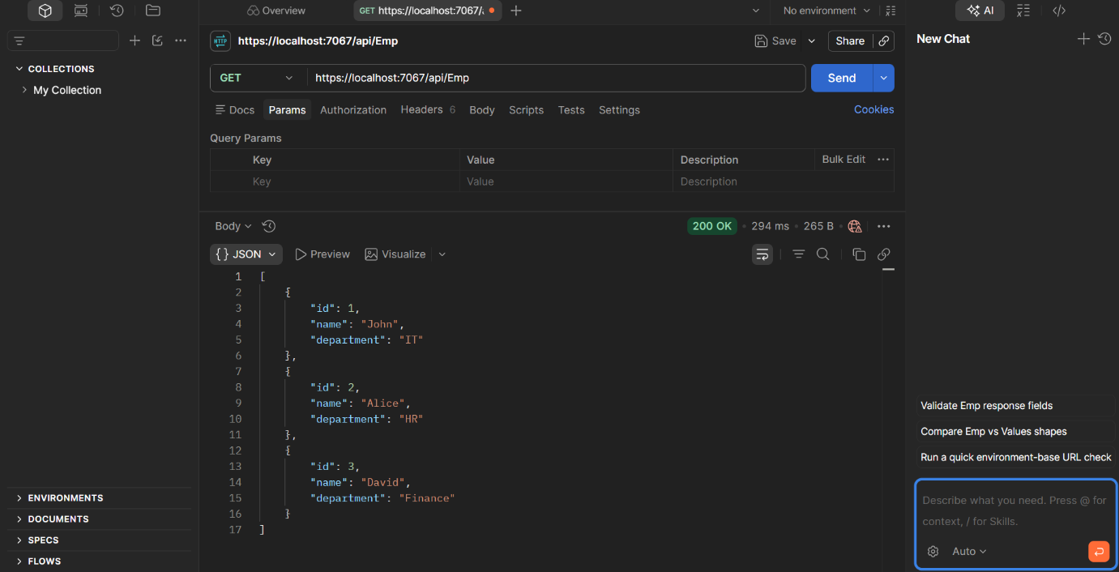

Figure 5: EmployeeController showing the modified route:
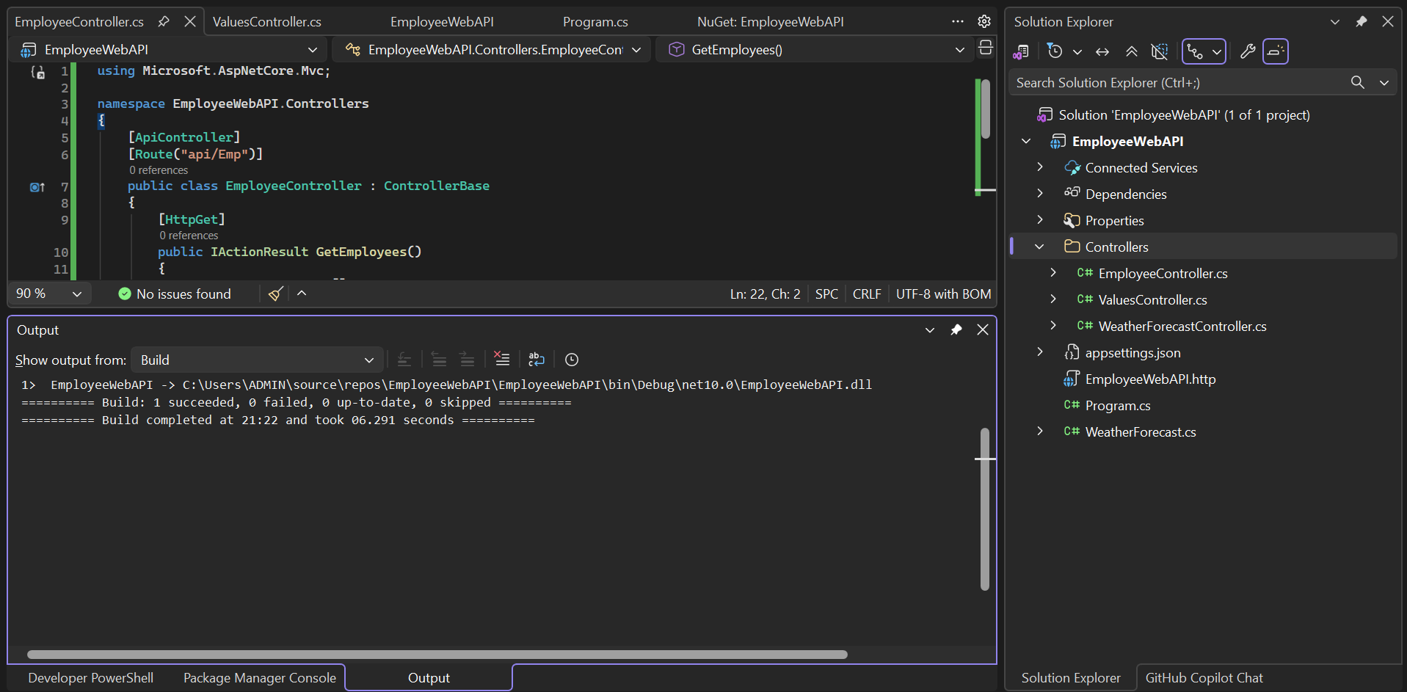

Result
Successfully created an ASP.NET Core Web API and configured Swagger. The API endpoints were tested successfully using both Swagger UI and Postman. The Employee controller route was modified to api/Emp, and the updated endpoint returned the employee list successfully with 200 OK status.

